Blood Life
A Smart System to Find Blood Donors Quickly

Project Team
Team Members:
- Deversh Shetgaonkar (2302)
- Atharv Gawas (2313)
- Shripad Chodankar (2317)

What is This Project About?
The Blood life is a computer application developed using C++ programming language. It helps hospitals and blood banks find blood donors quickly during emergencies. The application uses Qt (a framework for creating graphical user interfaces) and MySQL (a database management system to store information).
What makes this application special is that it implements a multi-stage verification and availability system. Donors must first be approved by administrators before appearing in searches, and they can control their real-time availability status. This smart feature ensures that hospitals only contact verified, available donors, saving critical time during emergencies.

The Problem We Are Solving
Why Do We Need This System?
When someone needs blood urgently in a hospital, finding a donor is very difficult. Here's why:
Current Problems:
Unorganized Communication:
- People make phone calls one by one to find donors, which takes too much time
- Donor information is written on paper or stored in different files with no organization
- There is no central place where all donor information is stored
- No verification system to ensure donor information is authentic
Confusion About Donor Status:
- No one knows if a donor recently gave blood (they need to wait 90 days before giving again)
- No way to tell if someone is busy, sick, or out of town right now
- Time is wasted calling unverified or unavailable people
- No approval process to confirm donor authenticity
No Planning for the Future:
- No one knows which blood types are needed most often
- Cannot predict when there will be a shortage of blood
- Cannot plan blood donation camps properly
- No data to analyze demand patterns
What Happens: Because of these problems, patients have to wait longer to get blood, which can be dangerous for their health. Hospitals waste time contacting unverified or unavailable donors, and blood banks cannot efficiently plan donation drives.

How Our System Solves These Problems
What Technology We Used
Programming Tools:
- C++ Language: The main programming language used to build the application
- Qt Framework: A tool that helps create buttons, windows, and menus with a graphical user interface
- MySQL Database: A secure place to store all donor information permanently
- Object-Oriented Design: A way of organizing code that makes it easier to build, maintain, and improve
How We Organized the Code:
Our system uses independent classes rather than inheritance:
- Donor Class: Manages all donor-related information and registration requests
- Hospital Class: Handles blood search requests from medical facilities
- Admin Class: Manages approval and verification processes
- DatabaseManager Class: Handles all database operations
- SearchLog Class: Tracks search patterns for analytics
- Analytics Class: Generates reports and visualizations
- GUIManager Class: Creates separate interfaces for different user types
This structure makes the code modular, maintainable, and easy to expand in the future.

What Can This Application Do?
1. Donor Registration and Approval System
Request Registration (Donor Action)
- Donors fill out a registration form with details: name, age, gender, blood group, phone number, and city
- The application validates that all required information is provided correctly
- Registration request is saved with status: approvalStatus = Approve/Reject
- Donor receives confirmation that their request is under review
Admin Approval Process
- Admin reviews all pending donor registration requests
- Admin can approve or reject each request
- Upon approval: approvalStatus = TRUE, donor gains access to the system
- Upon rejection: Admin can provide a reason, and the request is archived
- This ensures only verified donors are in the database
Donor Availability Toggle
- Once approved, donors receive access to a simple toggle button
- Donors can mark themselves as:
  - Available = TRUE: Ready to donate right now
  - Available = FALSE: Temporarily unavailable
- Donors can update this status anytime from their account
- This gives donors control over when they can donate.

2. Hospital Search Interface
Multi-Stage Filtering Process
When hospitals search for donors, the system applies three filters automatically:
Stage 1: Approval Verification
- Filter: approvalStatus = TRUE
- Shows only admin-verified donors
- Eliminates unverified or fake registrations
Stage 2: Availability Check
- Filter: available = TRUE
- Shows only donors who marked themselves as currently available
- Prevents wasting time on unavailable donors
Stage 3: Blood Type and Location Match
- Filter: Match bloodGroup (e.g., A+, O-, B+) and city
- Shows donors with the exact blood type needed
- Prioritizes donors in the same city for faster response
Result: Hospital sees a refined list of verified, available donors with the right blood type in their area.
3. Admin Management Panel
Approve Donor Requests
- View all pending registration requests
- Review donor information before approval
- Approve or reject with one click
- Track approval history and reasons for rejection
Remove Inactive Donors
- Identify donors who haven't been available for extended periods
- Remove donors who have moved away or are no longer interested
- Maintain a clean, active database
- Archive removed donor records for future reference
Manage Verified Database
- View statistics on total verified donors by blood group
- Monitor approval rates and rejection reasons
- Ensure database quality and accuracy
- Generate reports on donor demographics
4. Tracking Donor Eligibility
The 90-Day Rule
When someone donates blood, they need to rest for 90 days before donating again. Our application:
- Automatically records the date when someone donates
- Calculates when they can donate again (90 days later)
- Shows them as "Not Eligible" until the time is up
- Automatically changes status to "Eligible" after 90 days
- Prevents donors from being contacted during rest period
Health Check Tracking
Before donating, people need medical tests. The application:
- Tracks whether someone completed their health tests
- Shows only fully tested donors in urgent searches
- Maintains health test expiration dates
- Keeps everyone safe and healthy
5. Complete Donation History
What We Track:
- Every time someone donates blood, we record the date, location, and hospital
- Track total number of donations per donor
- Monitor donation frequency and patterns
- Recognize regular donors and thank them
Why This is Useful:
- Know exactly when someone last donated
- Calculate 90-day eligibility automatically
- Identify experienced donors vs. first-time donors
- Find people who haven't donated recently and send reminders
- Award recognition to frequent donors
6. Understanding Demand Patterns with Analytics
Monthly Reports:
- See which blood groups were needed most each month
- Identify which areas have the most requests
- Understand seasonal patterns and trends
- Compare current month with previous months
Planning for the Future:
- Know when to organize blood donation camps
- Focus on collecting blood types that are needed most
- Allocate resources efficiently
- Target donor recruitment for scarce blood types
Types of Reports:
- Charts showing blood group demand by month
- Geographic maps showing which cities need more donors
- Statistics about donor participation rates
- Approval vs. rejection rates
- Average response times for searches

UML Diagram – Blood Life
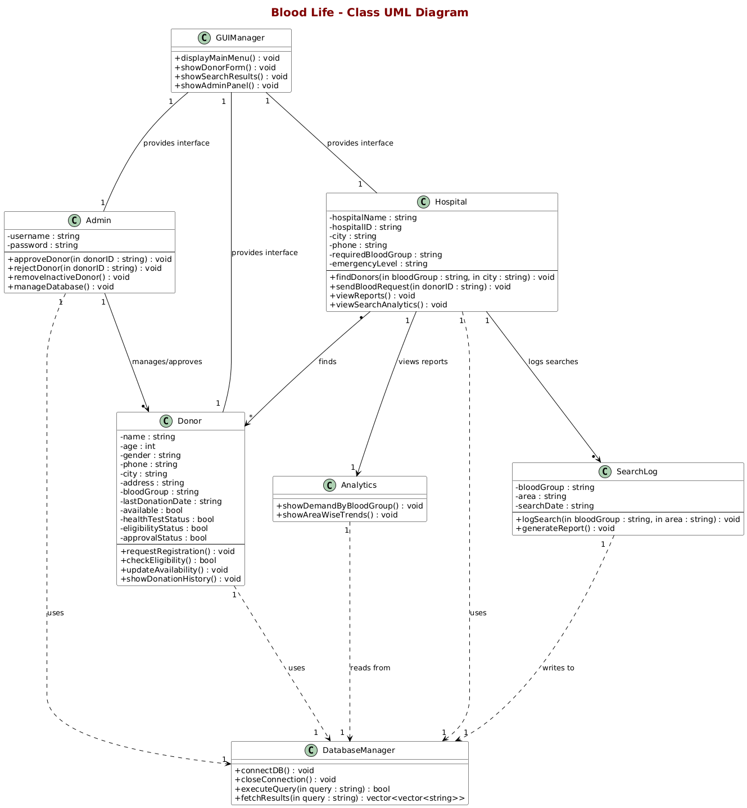

Who Benefits from This System?
For Hospitals and Blood Banks
- Save Time: Find verified, available donors in seconds instead of hours
- Accuracy: Don't waste time calling unavailable or unverified people
- Reliability: Access only admin-approved donors who can actually help
- Better Planning: Use analytics to plan donation camps strategically

For Blood Donors
- Control: Mark yourself as available or unavailable anytime
- Respect: Won't be bothered during rest periods or when unavailable
- Recognition: See complete history of all donations and contributions
- Verification: Registration approval ensures community trust
For Administrators
- Quality Control: Approve only legitimate donor registrations
- Database Management: Maintain a clean, verified donor list
- Analytics Access: Generate reports to improve blood collection strategy
- Efficiency: Automate eligibility tracking and availability management
For Patients
- Faster Help: Get blood quickly in emergencies from verified sources
- Safety: Blood comes from properly tested and approved donors
- Reliability: Higher success rate in finding available donors

Key Features That Make Our System Unique
1. Three-Layer Verification
- Admin approval ensures donor authenticity
- Real-time availability prevents wasted contacts
- Medical eligibility protects both donors and recipients
2. User-Controlled Availability
- Donors have autonomy over their availability status
- Simple toggle mechanism for ease of use
- Reduces unnecessary calls and respects donor time
3. Data-Driven Planning
- Analytics identify blood shortage patterns
- Historical data guides donation camp planning
- Resource allocation based on actual demand
4. Role-Based Interfaces
- Separate interfaces for Donors, Hospitals, and Admins
- Each user sees only relevant features
- Streamlined experience for all stakeholders

Future Improvements We Can Make
Technical Enhancements
- Create a mobile application so donors can update their status from smartphones
- Send automated SMS or email alerts when urgent blood is needed
- Implement a web-based portal accessible from any device
- Add biometric authentication for enhanced security
Advanced Features
- Use artificial intelligence to predict future blood needs based on historical patterns
- Integrate with hospital management systems for seamless workflow
- Implement geolocation to find nearest available donors
- Add blood donation appointment scheduling system
Gamification and Engagement
- Create achievement badges and recognition for frequent donors
- Implement a points system to encourage regular donations
- Show donors their impact: "Your donations have helped X patients"
- Create donor leaderboards and community challenges
- Send milestone notifications (10th donation, 5 years of donating, etc.)
Communication Improvements
- Multi-language support for wider accessibility
- Push notifications for urgent requests
- In-app messaging between hospitals and donors
- Automated reminders when donors become eligible again

Conclusion
The Blood life transforms how we connect blood donors with those in need. Instead of making hundreds of phone calls and hoping for the best, we now have an intelligent, multi-layered system that ensures only verified, available, and eligible donors are contacted.
The three-stage filtering process (admin approval, donor availability, and blood type matching) ensures that hospitals waste no time during critical emergencies. By giving donors control over their availability and implementing a robust approval system, we respect donor autonomy while maintaining database quality.
By tracking donation history, automating eligibility calculations, and providing powerful analytics, this system not only saves time but can actually save lives by ensuring the right donor is found at the right moment. The separate interfaces for donors, hospitals, and administrators make the system intuitive and efficient for all stakeholders.
This is more than just a database—it's a comprehensive blood donor management ecosystem that addresses real-world challenges with practical, technology-driven solutions. It's simple to use, intelligent in how it operates, and solves a critical problem that affects people every day.

